Exercise 3 – Branching and Merging

Step 1
Create Branch
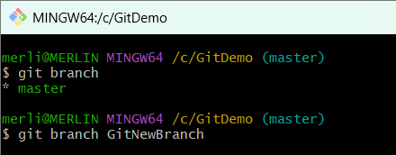
Step 2
List Branches
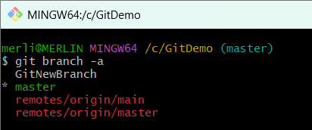
Step 3
Switch Branch
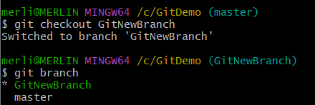

Step 4
Create File
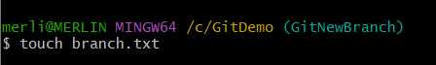

Step 5
Edit File
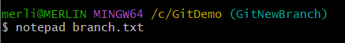
Content
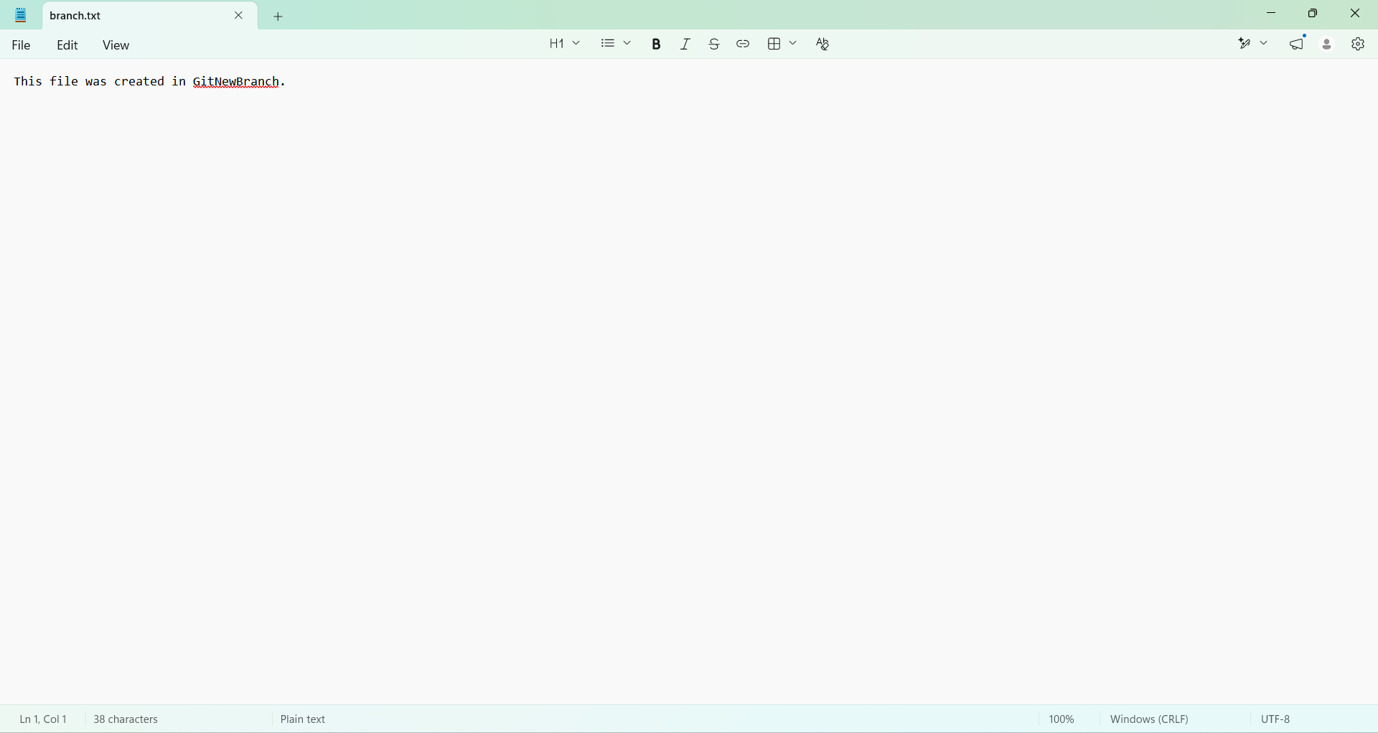
Step 6
Commit
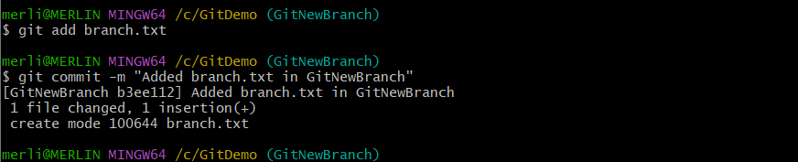
Step 7
Switch Master

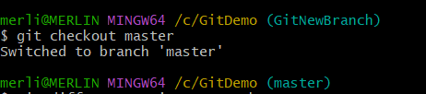

Step 8
Merge
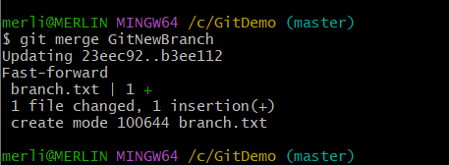
Step 9
Log
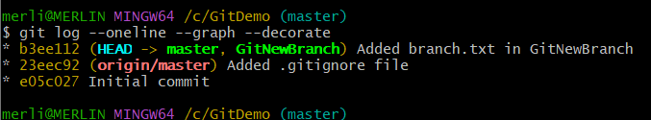
Step 10
Delete Branch
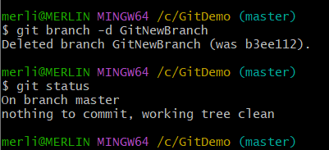
Step 11
Push
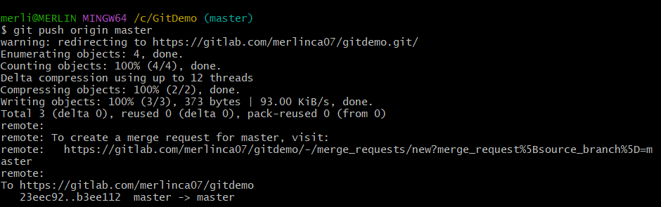
Gitlab repository link :
MERLIN C A / GitDemo · GitLab

